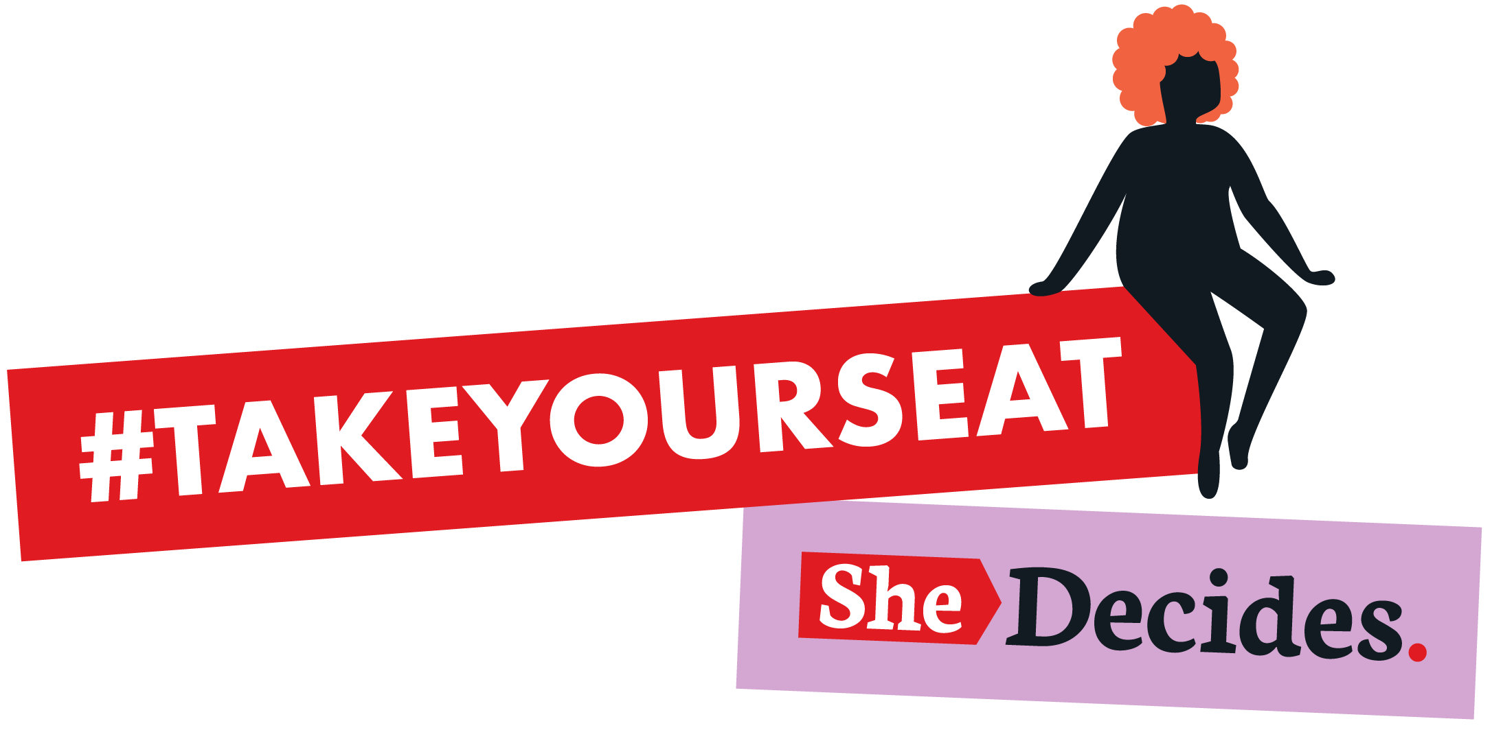

Regional release

We need to talk more about [topic] in [location]

- [Location] is part of the growing movement of women and girls around the world who are demanding that their voices are heard and are at the core of decisions about their bodies.
- [Location] is marking SheDecides Day, the global day of activism driving change for bodily autonomy on 2 March, by [insert your planned SD Day activities]
- Women, girls, activists and allies including [add collective, movement, individual names if appropriate] are leading the charge, sharing experiences and challenging taboos, using the #TakeYourSeat card game launched today by SheDecides

[Today], activists in [location] are [insert your planned SD Day activities] as part of #TakeYourSeat, the campaign marking SheDecides Day, the global day of activism driving change around bodily autonomy on 2 March.

[Insert more information about the activity - number and diversity of participants, organisations, the themes or topics discussed, whether the #TakeYourSeat card game was used]

The #TakeYourSeat card game from SheDecides officially launches today, to spark challenging reflections about bodily autonomy issues, such as [include topics of focus from activity]. The silence on these topics, and the taboos that surround these conversations, has led to myths and misinformation and women and girls being denied their right to decide. The #TakeYourSeat card game is designed to encourage conversation to claim back that space, to raise the voices of women and girls, and to spark powerful conversations about their bodies , their lives and their future.

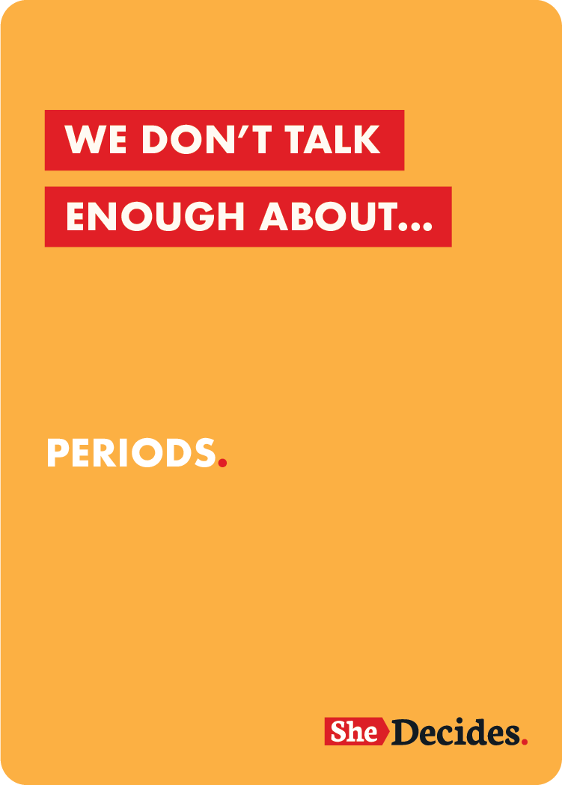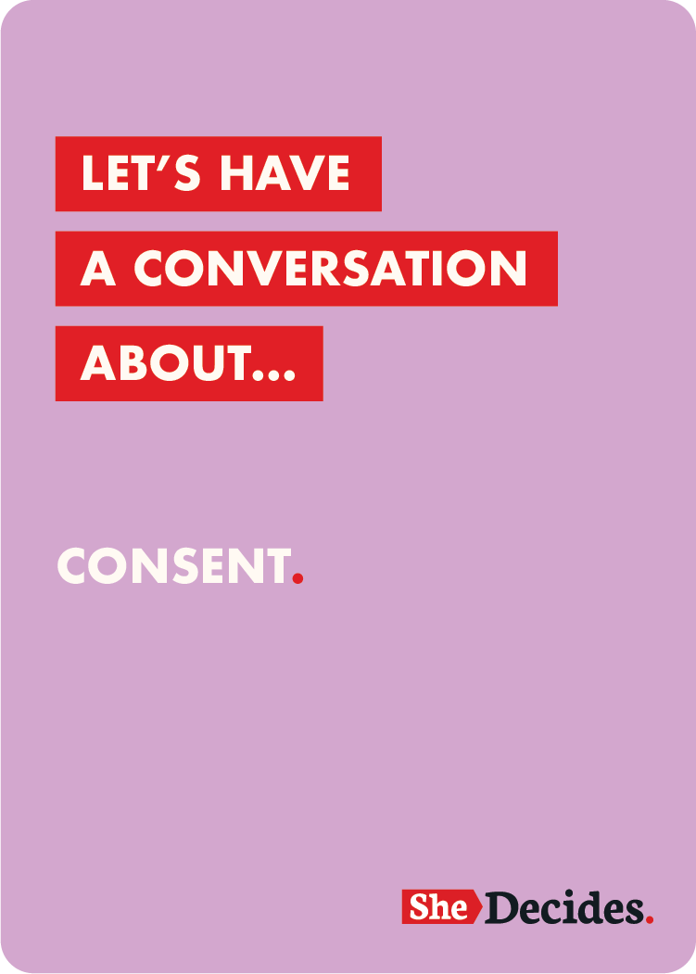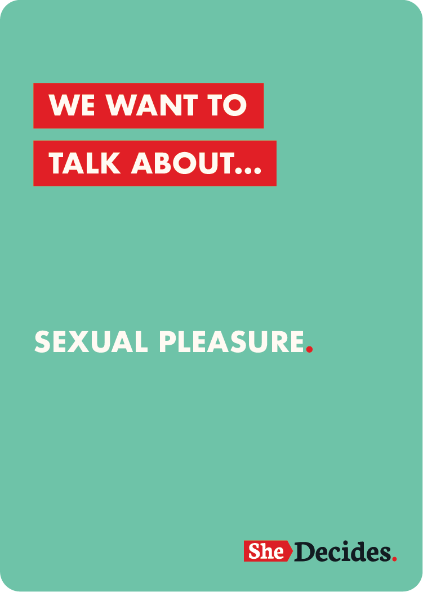

[Movement spokesperson] said:
“All too often, women and girls are prevented from taking their rightful place in conversations about their bodies, lives and futures. #TakeYourSeat is a moment to claim that space, and start a conversation about women and girls’ right to decide. Personalise with the specific issue areas that are silenced in location, the importance of SheDecides Day activities to spark conversations and change about them.

When people stand up and speak out to demand women and girls’ seat at the table, they create a wave of global voices and a movement of positive pressure. Through #TakeYourSeat, SheDecides aims to amplify this push to dismantle the harmful stigmas around bodily autonomy.

About [location movement, collective]:
Insert boilerplate

About SheDecides

SheDecides is a global political movement driving change for bodily autonomy, fuelled by actions in communities with young people at its heart. SheDecides was launched at the start of 2017 and is guided by the vision as articulated in the SheDecides Manifesto: A new normal where girls and women decide about their bodies, their lives, their futures. Without question.

SheDecides Day is a global day of activism on 2 March 2021. It is an opportunity to demonstrate our collective commitment to the right of every girl and every woman, everywhere, in all their diversity, to make the decisions only she should make.

#TakeYourSeat is the theme for SheDecides Day 2021. It refers to the power of being at the table and at the center of the discussion. It reinforces the message that all too often, women and girls are not given or are prevented from taking their rightful place in conversations about their bodies, lives and futures.

This is a moment where women and girls are taking their seat at the table, making their voices heard, and sparking powerful conversations about topics that are silenced through stigma. The day will start conversations about bodily autonomy, to speak out about experiences and to break these stigmas.

www.shedecides.com

